# **AI-Powered Chatbot U**sing AWS

### **Project Description:**

The AI-powered chatbot will be built using a combination of Amazon Web Services (AWS) offerings, including Amazon Lex, AWS Lambda, Amazon DynamoDB, Amazon S3, Amazon API Gateway, and Amazon CloudWatch. The chatbot will use natural language processing (NLP) to understand and respond to user queries. It will be capable of handling multiple intents, managing user sessions, and storing user data securely.

### **Scenarios:**

**Scenario 1: Customer Support on E-commerce Website**

A customer visits an e-commerce website and interacts with the chatbot to inquire about the status of their order. The chatbot, powered by Amazon Lex, recognizes the query and fetches the order details using data from the backend database (DynamoDB). It provides an accurate and timely response, improving the customer experience by resolving their query instantly. If needed, the chatbot escalates the issue to a live agent via integration with API Gateway. The use of AWS services ensures the chatbot is scalable and responsive during high traffic.

**Scenario 2: Educational Institution FAQ Bot**

A student accesses an educational institution’s website to find information about admission deadlines, course details, and campus facilities. The chatbot, using Amazon Lex, identifies various intents like "admission dates" or "course offerings" and responds accordingly with the relevant information stored in Amazon S3 and DynamoDB. The chatbot provides 24/7 assistance to students, reducing administrative workload. It also offers dynamic responses based on the student’s profile and query history. All interactions are logged in CloudWatch for monitoring and optimization.

**Scenario 3: Personal Assistant for Task Management**

A user interacts with a personal assistant chatbot to manage their daily tasks. The chatbot, built with AWS Lambda and Amazon Lex, understands tasks like “schedule meeting,” “set reminders,” or “check today’s agenda.” It stores the user’s preferences and tasks in DynamoDB, allowing the bot to retrieve and update the user’s to-do list. Through voice recognition (if integrated with Amazon Polly), it can even set reminders with voice commands. This increases productivity by offering hands-free task management on mobile devices or desktops.



### **AWS ARCHITECTURE**

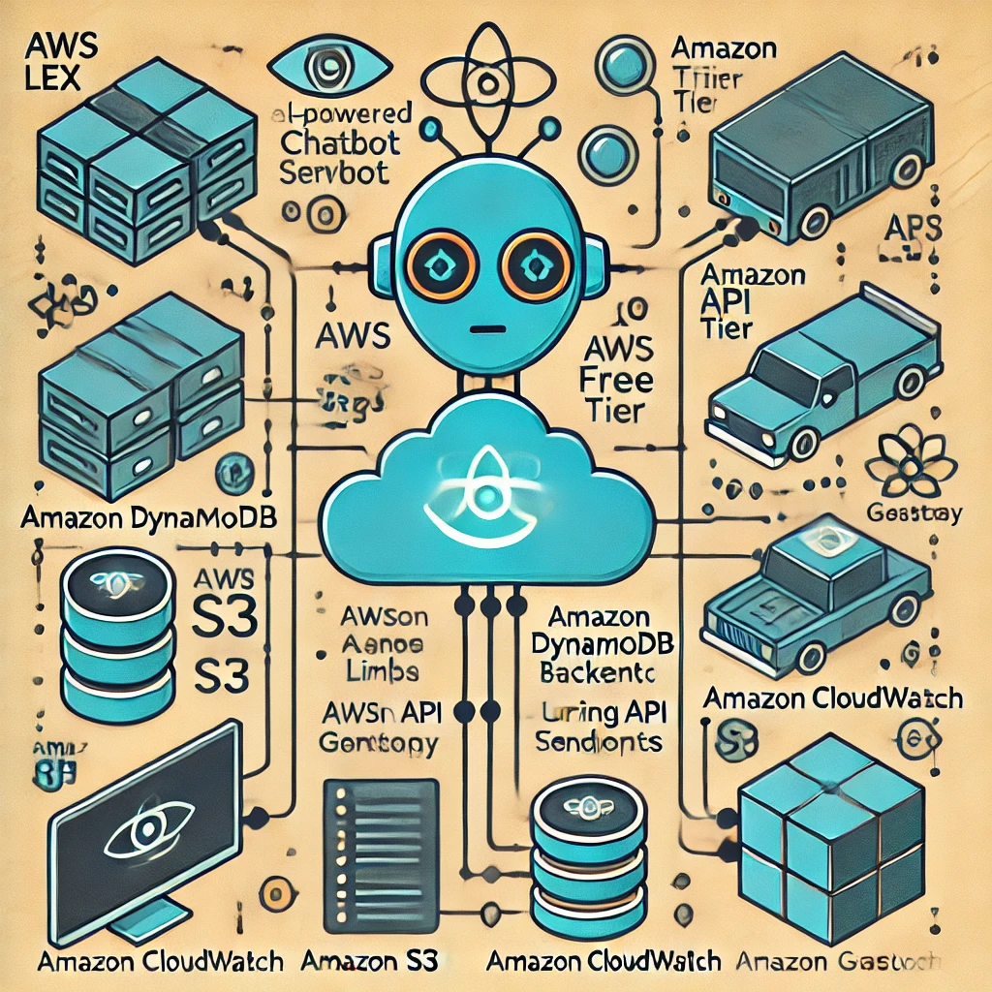

### Pre-requisites:

1. AWS Account Setup: [https://youtu.be/CjKhQoYeR4Q?si=ui8Bvk_M4FfVM-D](https://youtu.be/CjKhQoYeR4Q?si=ui8Bvk_M4FfVM-Dh)h

2. Understanding of Amazon LEX: <https://youtu.be/gsgdAyGhV0o?si=3qg-bULgkD4LXNvR>

3. Knowledge of Amazon DynamoDB :<https://youtu.be/8TlukLu11Yo?si=MUj0nEAOESRhHUIz>

4. S3 : <https://www.youtube.com/live/MPau9c7PT74?si=A8OK-zFGbSKkAFWN>

5. Cloud Watch: <https://youtu.be/wALCw0F8e9M?si=ovMF9qMx5rLxaznB>

### Project WorkFlow:

Phase 1: Setting Up AWS Services

1. Activity 1: Create AWS Account
   * Activity 1.1: Sign up for an AWS account.
   * Activity 1.2: Enable Free Tier usage.
2. Activity 2: Set Up Amazon Lex
   * Activity 2.1: Navigate to the Amazon Lex Console.
   * Activity 2.2: Create a new Lex bot.
   * Activity 2.3: Define intents, sample utterances, and slots.
   * Activity 2.4: Configure fulfillment to use Lambda.
3. Activity 3: Create a Lambda Function
   * Activity 3.1: Navigate to the AWS Lambda Console.
   * Activity 3.2: Create a new Lambda function.
   * Activity 3.3: Write and deploy the Lambda function code.
   * Activity 3.4: Integrate the Lambda function with Lex.

Phase 2: Building the Chatbot

1. Activity 4: Set Up Amazon DynamoDB
   * Activity 4.1: Navigate to the DynamoDB Console.
   * Activity 4.2: Create a new DynamoDB table.
   * Activity 4.3: Configure the table schema (e.g., primary key).
2. Activity 5: Store Static Content in Amazon S3
   * Activity 5.1: Navigate to the S3 Console.
   * Activity 5.2: Create a new S3 bucket.
   * Activity 5.3: Upload static content (images, response templates).

Phase 3: Frontend Integration

1. Activity 6: Create an API with Amazon API Gateway
   * Activity 6.1: Navigate to the API Gateway Console.
   * Activity 6.2: Create a new REST API.
   * Activity 6.3: Define routes and methods.
   * Activity 6.4: Integrate API Gateway with Lambda functions.
2. Activity 7: Design the Frontend
   * Activity 7.1: Develop a web interface for user interaction.
   * Activity 7.2: Integrate the web interface with API Gateway.
   * Activity 7.3: Implement user input handling and API requests.

Phase 4: Monitoring and Optimization

1. Activity 8: Monitor Logs with CloudWatch
   * Activity 8.1: Navigate to the CloudWatch Console.
   * Activity 8.2: Review Lambda and API Gateway logs.
   * Activity 8.3: Set up metrics and dashboards.
2. Activity 9: Set Up Alerts (Optional)
   * Activity 9.1: Create CloudWatch alarms for monitoring.
   * Activity 9.2: Configure notifications via SNS.

Phase 5: Testing and Deployment

1. Activity 10: Test the Chatbot
   * Activity 10.1: Test interactions in the Lex console.
   * Activity 10.2: Test the web interface and API integrations.
2. Activity 11: Deploy the Chatbot
   * Activity 11.1: Deploy the chatbot to the desired platform.
   * Activity 11.2: Verify functionality and performance.

### Milestones:-

#### Milestone 1: Initial Setup

* + Activity 1: Create AWS Account
    - 1.1: Sign up for an AWS account..
    - 1.2: Enable Free Tier usage.

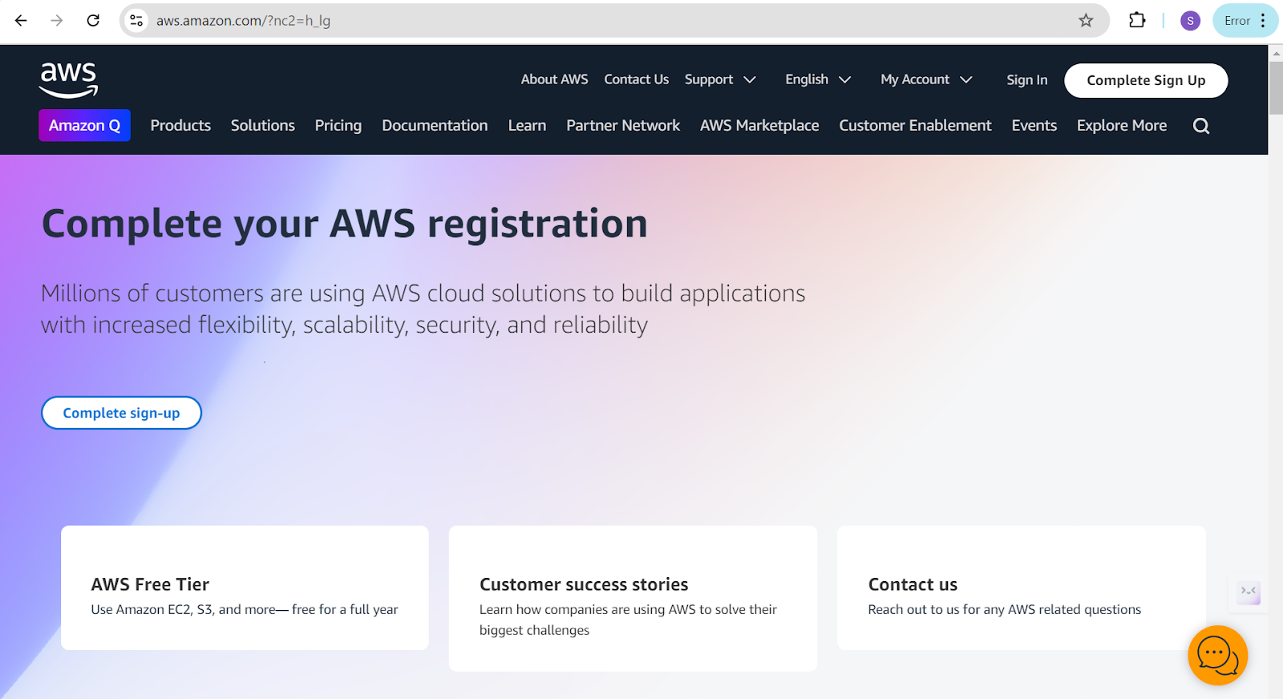

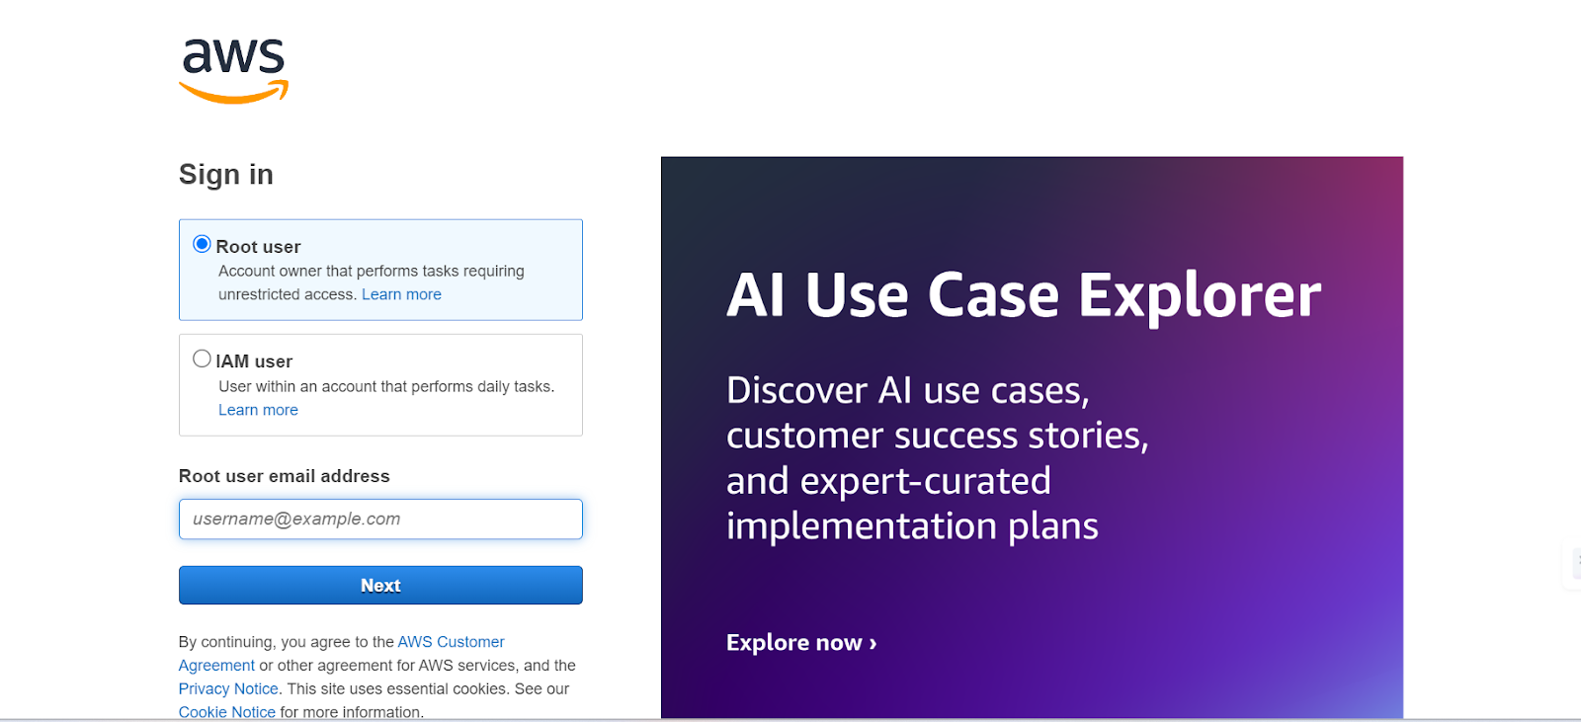

* + Activity 2: Set Up Amazon Lex
    - 2.1: Navigate to the Amazon Lex Console.

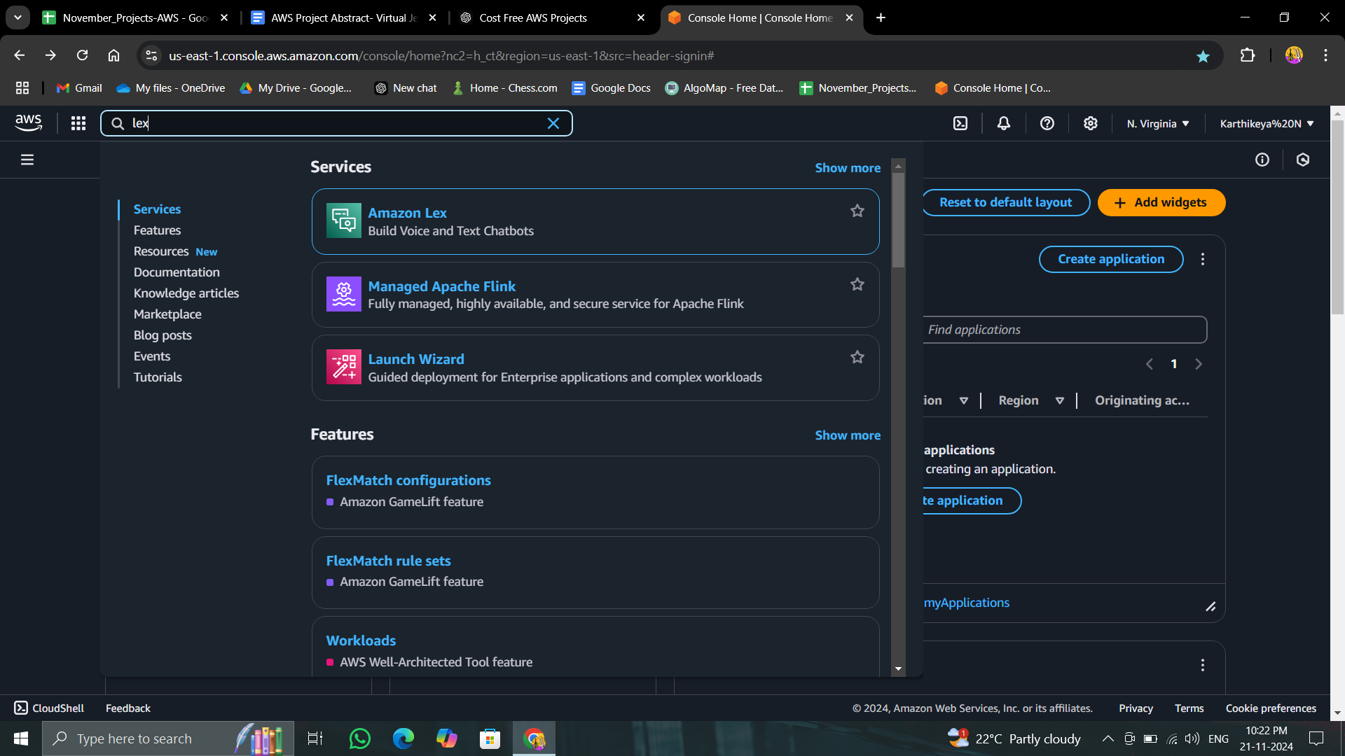

* + - 2.2: Create a new Lex bot.

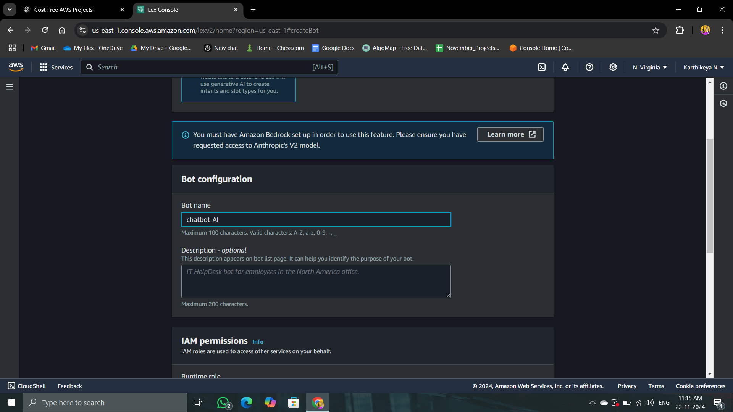

* + - 2.3: Define intents, sample utterances, and slots.
    - 2.4: Configure fulfillment to use Lambda.

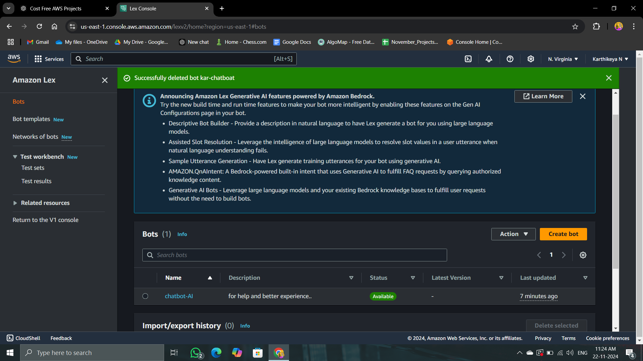

#### 

#### 

#### 

#### 

#### Milestone 2: Backend Development

* + Activity 3: Create a Lambda Function
    - 3.1: Navigate to the AWS Lambda Console.

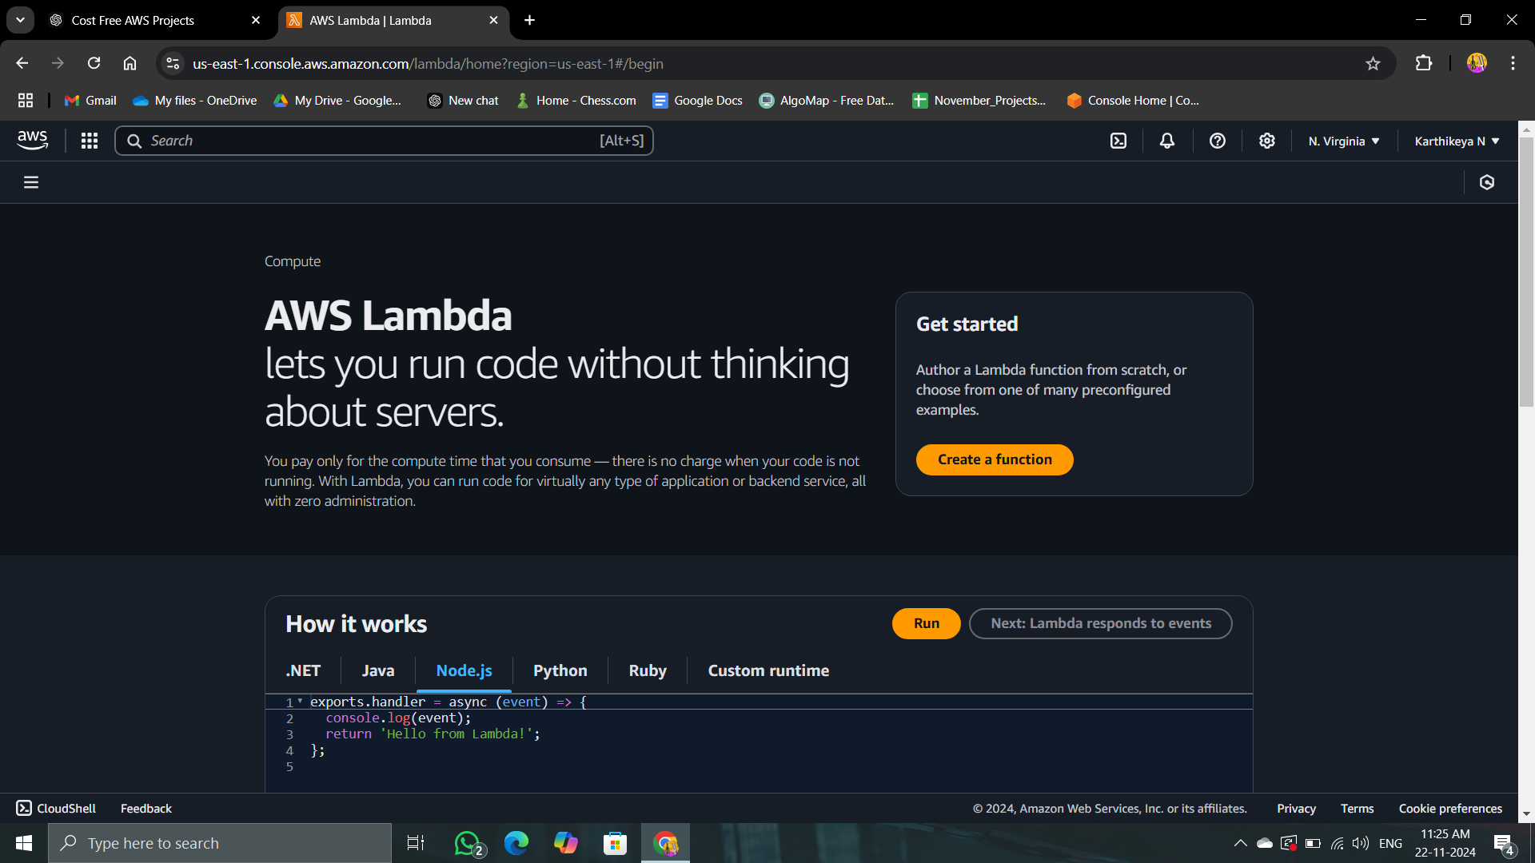

* + - 3.2: Create a new Lambda function.

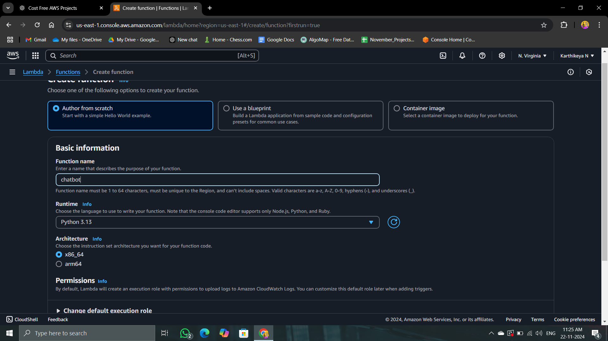

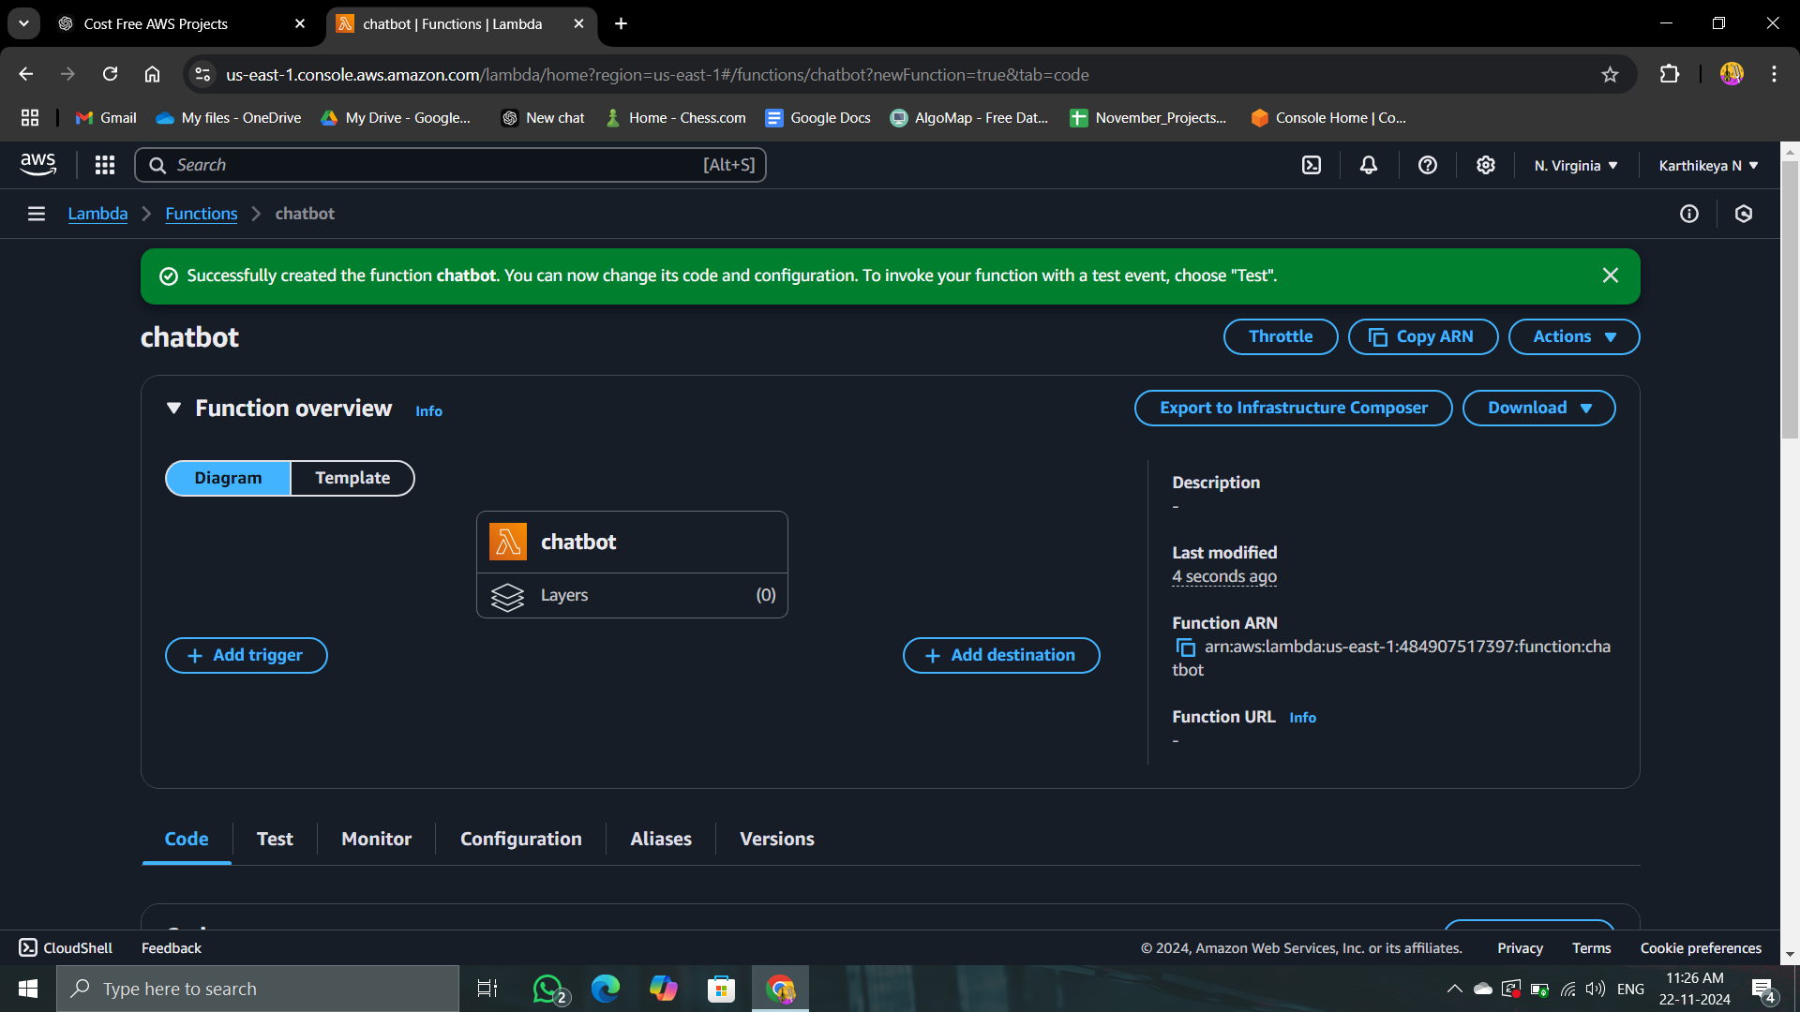

* + - 3.3: Write and deploy the Lambda function code.
    - 3.4: Integrate the Lambda function with Lex.

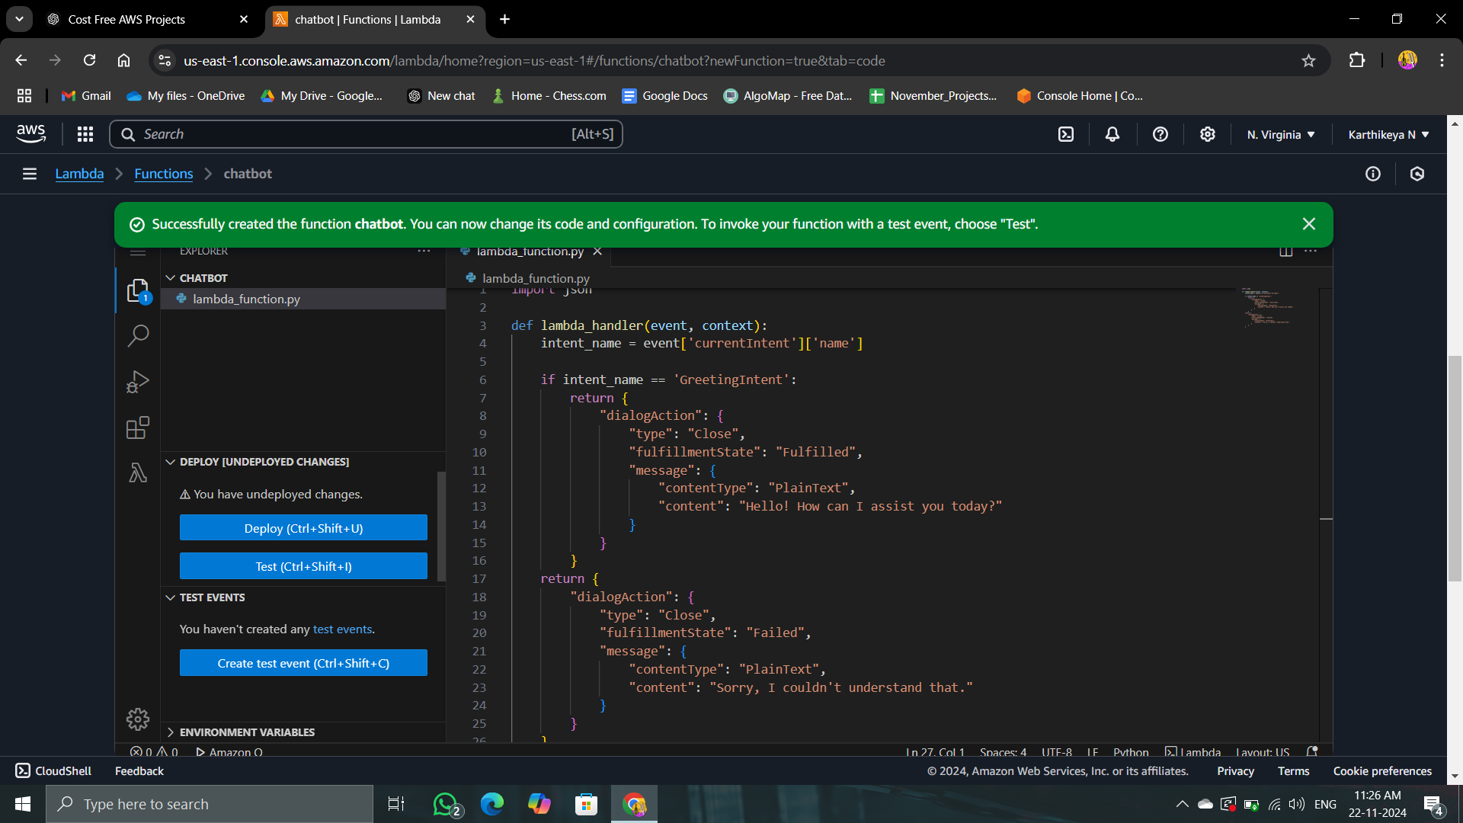

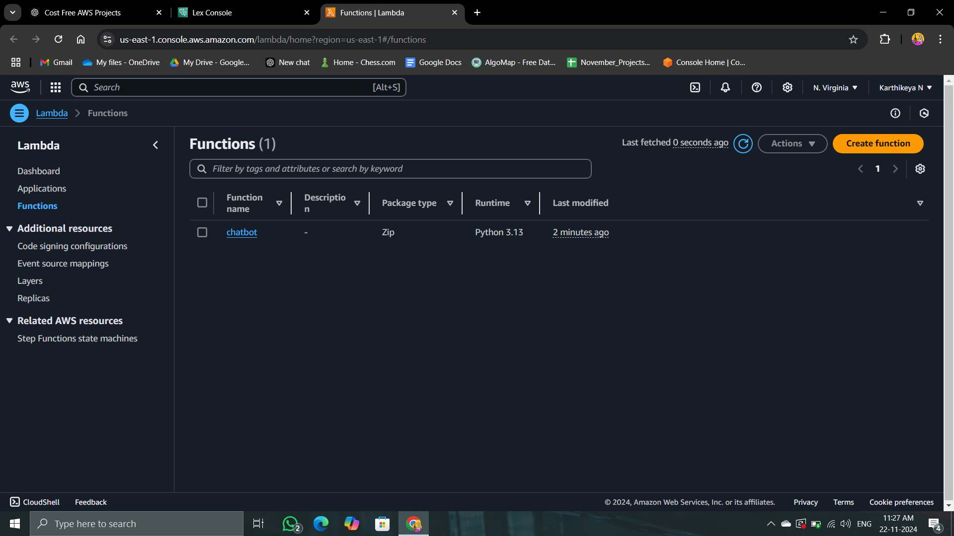

* + Activity 4: Set Up Amazon DynamoDB
    - 4.1: Navigate to the DynamoDB Console.

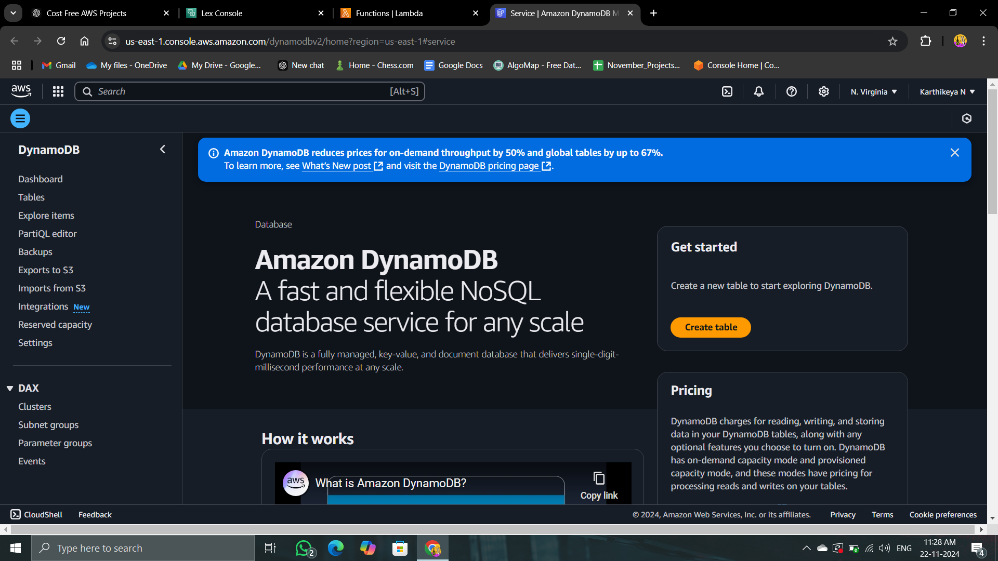

* + - 4.2: Create a new DynamoDB table.

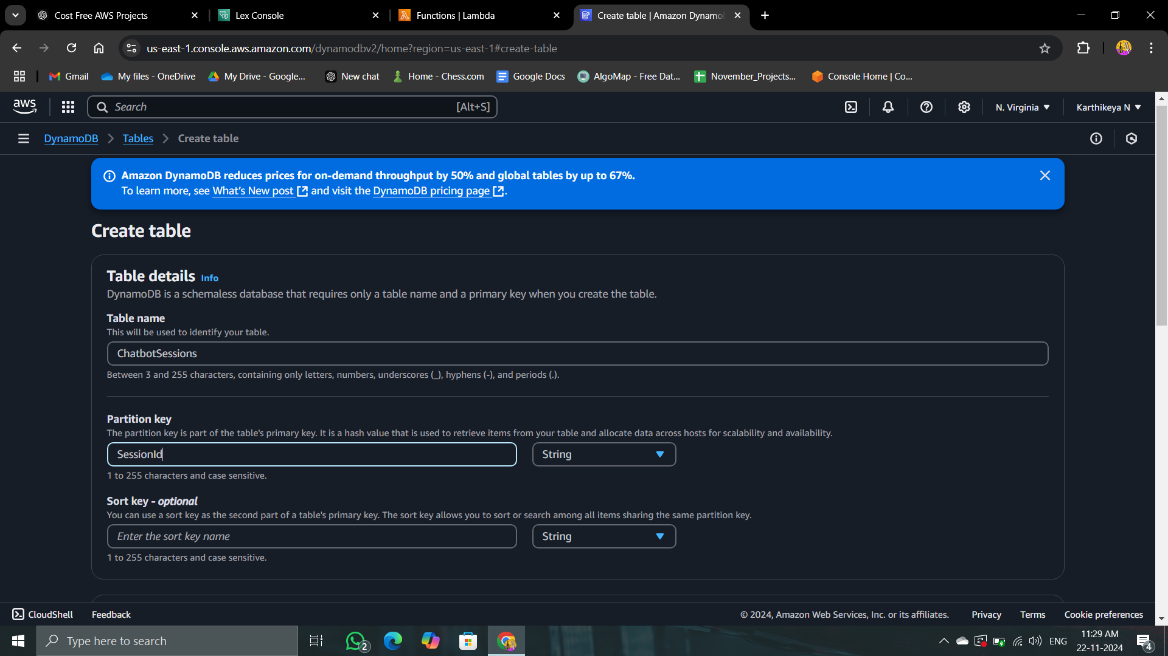

* + - 4.3: Configure the table schema (e.g., primary key).

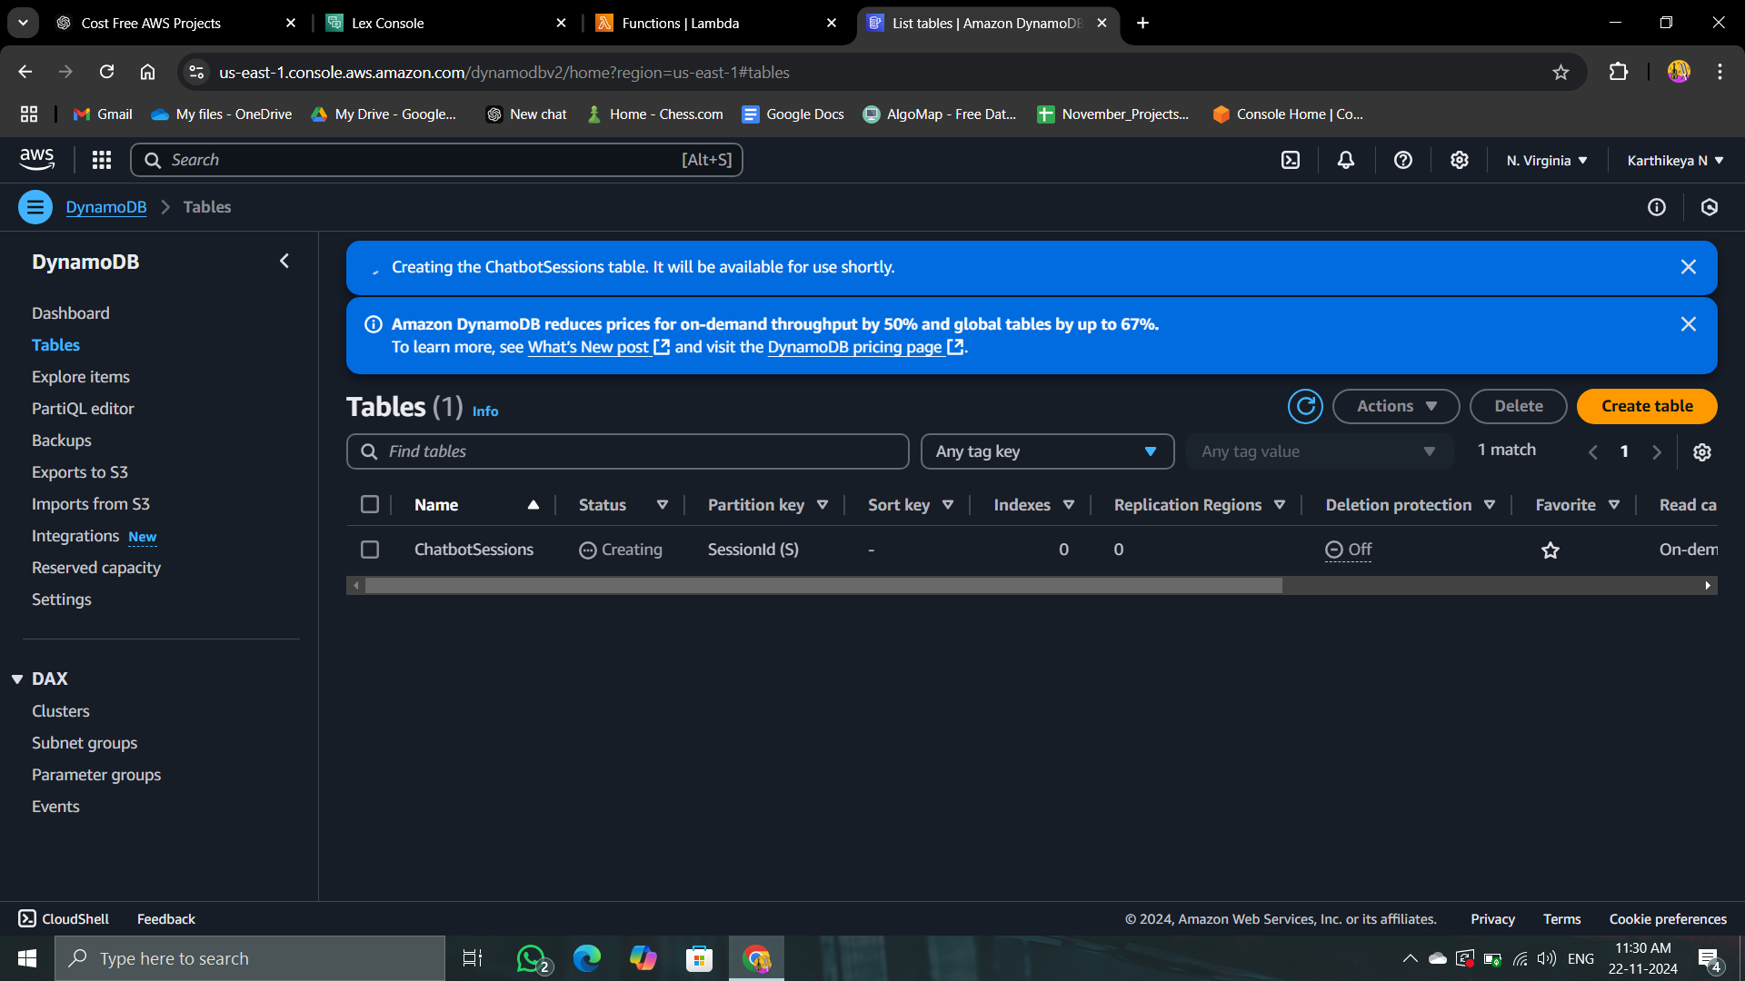

#### 

#### 

#### 

#### 

#### 

#### Milestone 3: Static Content Management

* + Activity 5: Store Static Content in Amazon S3
    - 5.1: Navigate to the S3 Console.

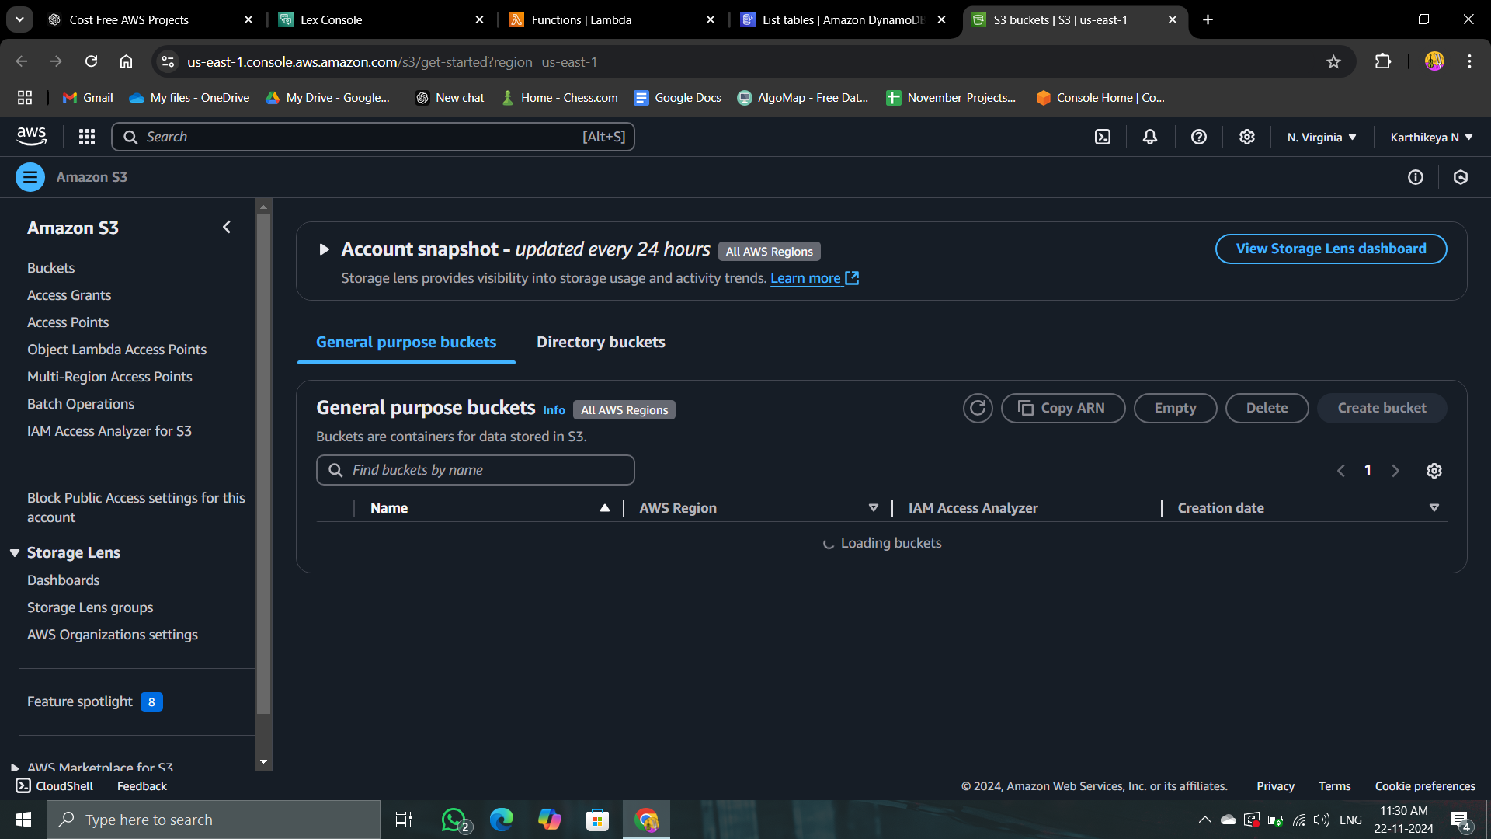

* + - 5.2: Create a new S3 bucket.
    - 5.3: Upload static content (images, response templates).

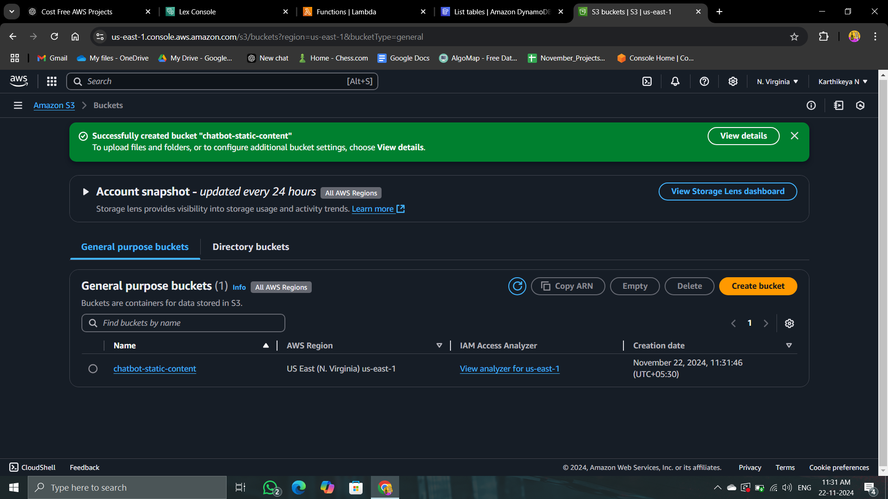

#### 

#### 

#### Milestone 4: API Integration

* + Activity 6: Create an API with Amazon API Gateway
    - 6.1: Navigate to the API Gateway Console.

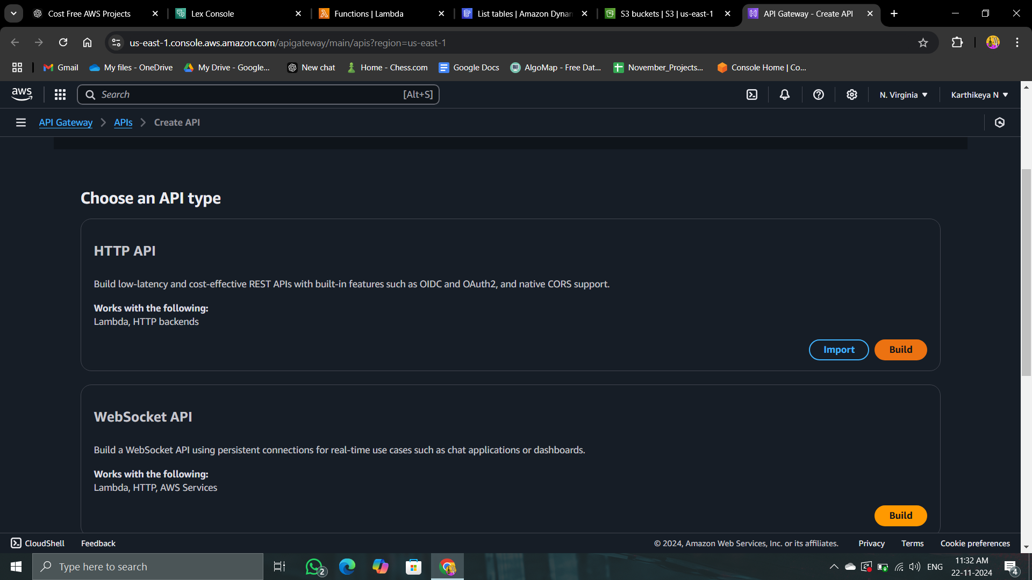

* + - 6.2: Create a new REST API.

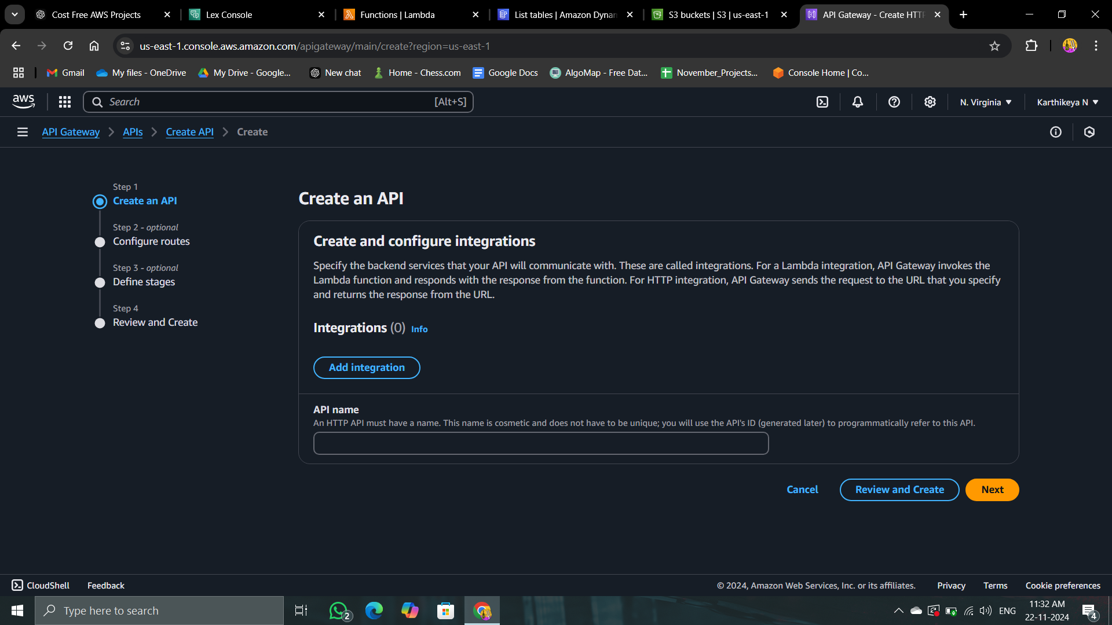

* + - 6.3: Define routes and methods.

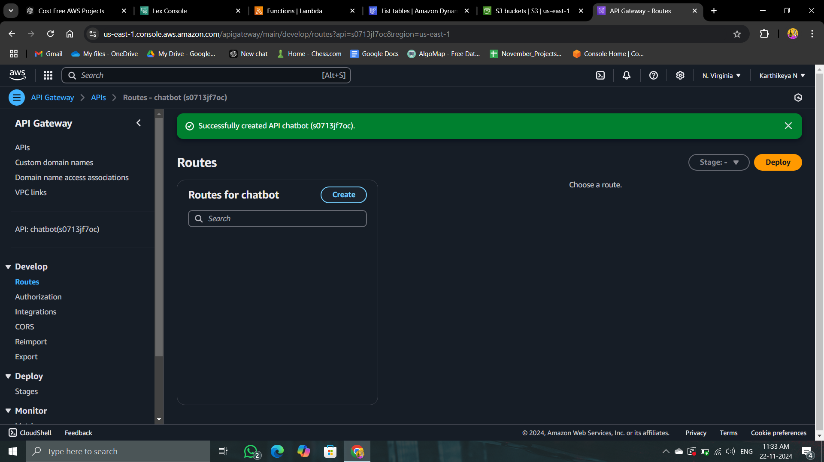

* + - 6.4: Integrate API Gateway with Lambda functions.

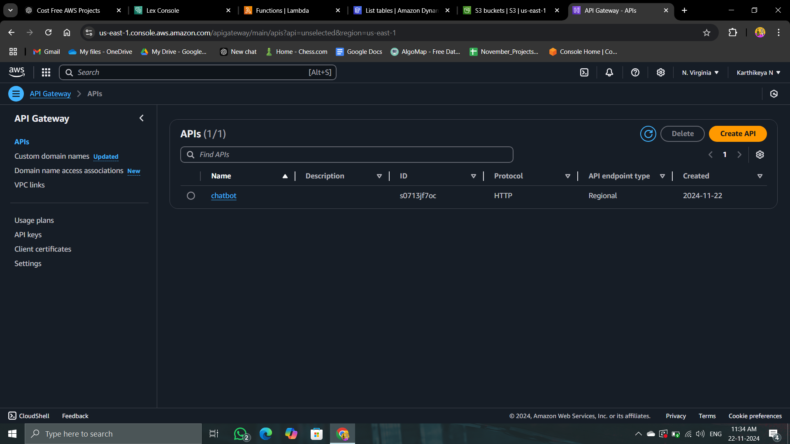

#### 

#### 

#### 

#### 

#### 

#### Milestone 5: Frontend Development

* + Activity 7: Design the Frontend
    - 7.1: Develop a web interface for user interaction.

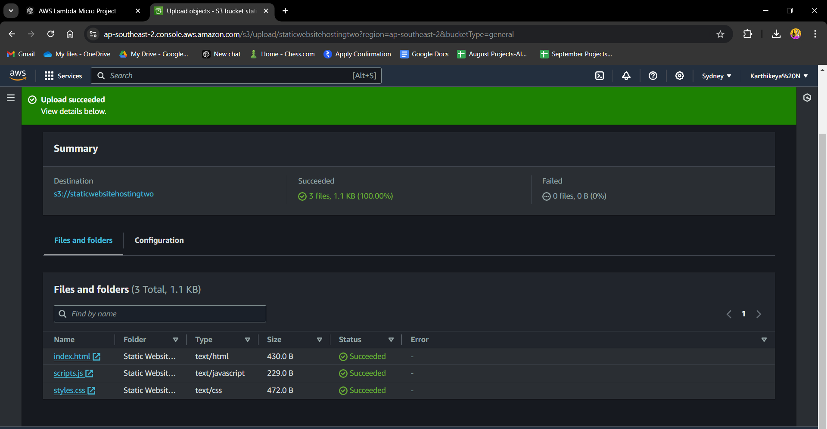

Html:

<!DOCTYPE html>

<html lang="en">

<head>

<meta charset="UTF-8">

<meta name="viewport" content="width=device-width, initial-scale=1.0">

<title>Chatbot</title>

<link href="https://stackpath.bootstrapcdn.com/bootstrap/4.5.2/css/bootstrap.min.css" rel="stylesheet">

<link rel="stylesheet" href="styles.css">

</head>

<body>

<div class="container">

<div class="row justify-content-center">

<div class="col-md-6">

<div class="card mt-5">

<div class="card-header text-center">

<h2>Chatbot</h2>

</div>

<div class="card-body">

<div id="chat-box" class="chat-box"></div>

<div class="input-group mt-3">

<input type="text" id="user-input" class="form-control" placeholder="Type a message...">

<div class="input-group-append">

<button class="btn btn-primary" onclick="sendMessage()">Send</button>

</div>

</div>

</div>

</div>

</div>

</div>

</div>

<script src="script.js"></script>

<script src="https://code.jquery.com/jquery-3.5.1.slim.min.js"></script>

<script src="https://cdn.jsdelivr.net/npm/@popperjs/core@2.5.3/dist/umd/popper.min.js"></script>

<script src="https://stackpath.bootstrapcdn.com/bootstrap/4.5.2/js/bootstrap.min.js"></script>

</body>

</html>

JS:

async function sendMessage() {

const userInput = document.getElementById('user-input').value;

if (!userInput) return;

// Display the user's message

const chatBox = document.getElementById('chat-box');

const userMessage = document.createElement('p');

userMessage.textContent = `User: ${userInput}`;

chatBox.appendChild(userMessage);

// Clear the input field

document.getElementById('user-input').value = '';

// Send the message to the Flask backend

const response = await fetch('/chat', {

method: 'POST',

headers: {

'Content-Type': 'application/json'

 },

body: JSON.stringify({ message: userInput })

});

const data = await response.json();

// Display the bot's response

const botMessage = document.createElement('p');

botMessage.textContent = `Bot: ${data.response}`;

chatBox.appendChild(botMessage);

// Scroll to the bottom of the chat box

chatBox.scrollTop = chatBox.scrollHeight;

}

* + - 7.2: Integrate the web interface with API Gateway.
    - 7.3: Implement user input handling and API requests.

#### Milestone 6: Monitoring and Optimization

* + Activity 8: Monitor Logs with CloudWatch
    - 8.1: Navigate to the CloudWatch Console.

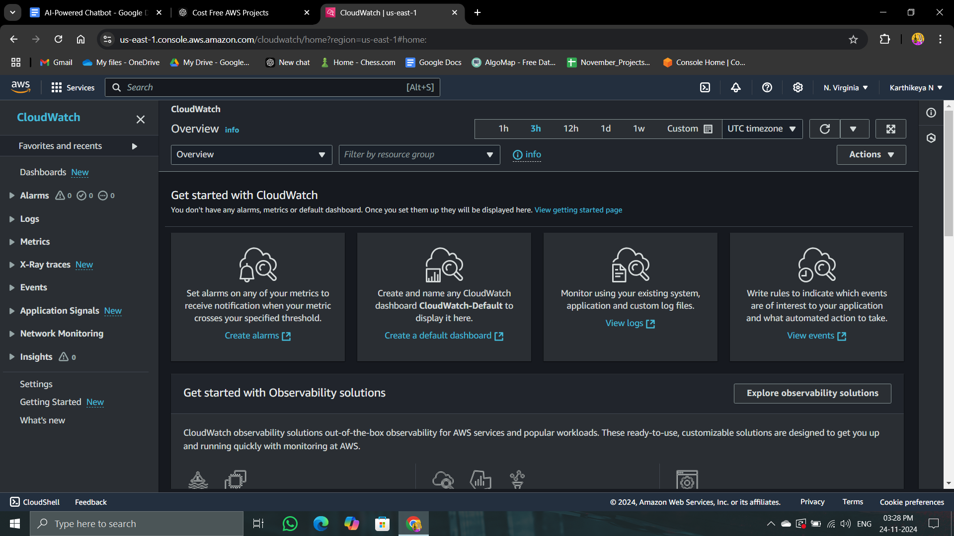

* + - 8.2: Review Lambda and API Gateway logs.
    - 8.3: Set up metrics and dashboards.
  + Activity 9: Set Up Alerts (Optional)
    - 9.1: Create CloudWatch alarms for monitoring.
    - 9.2: Configure notifications via SNS.

#### Milestone 7: Testing and Deployment

* + Activity 10: Test the Chatbot

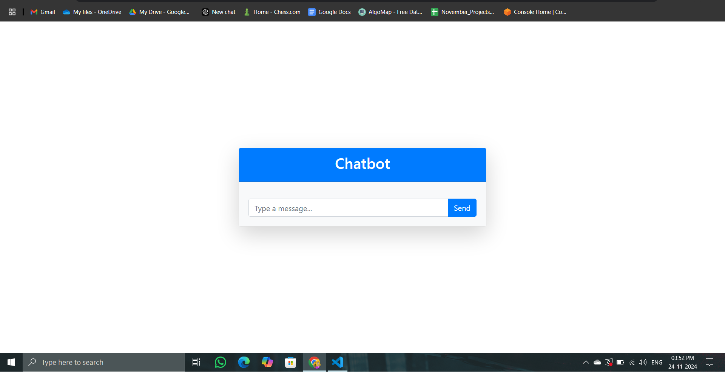

* + - 10.1: Test interactions in the Lex console.

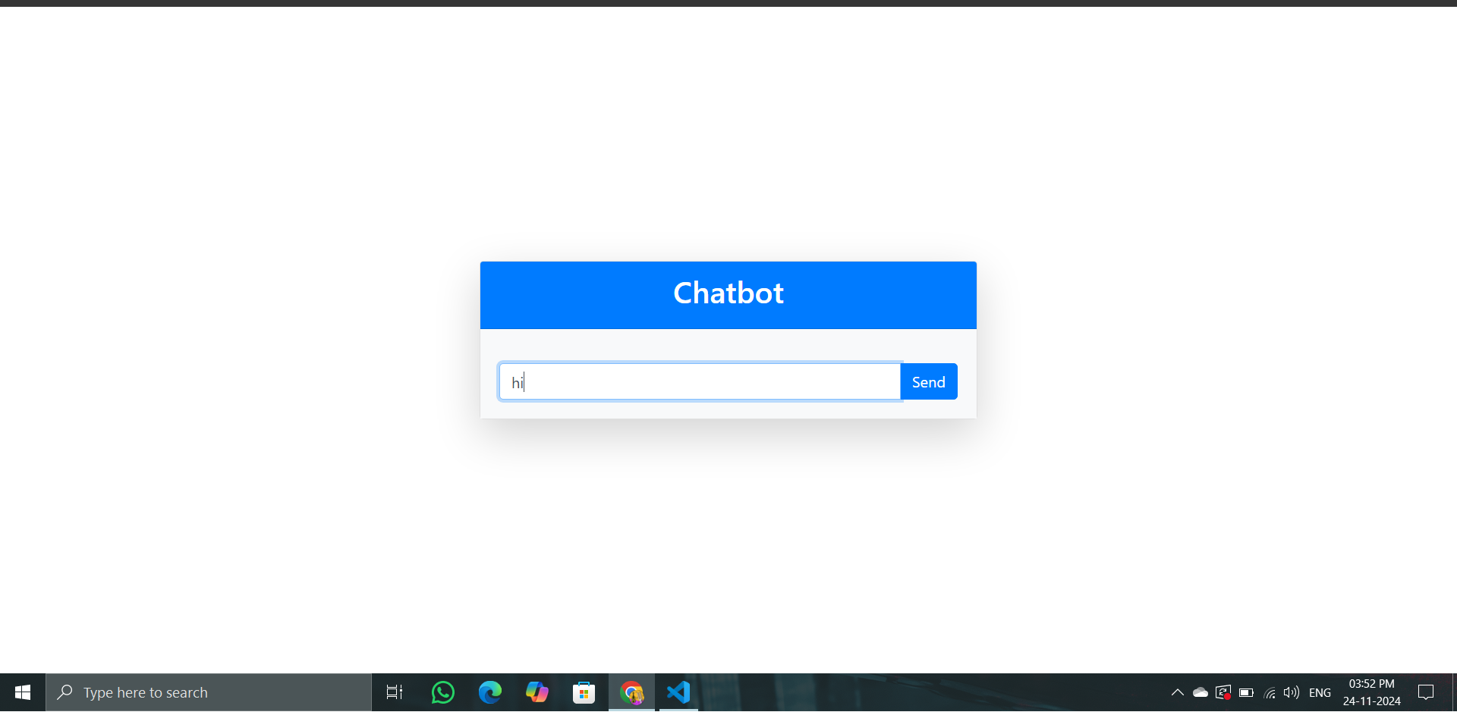

* + - 10.2: Test the web interface and API integrations.

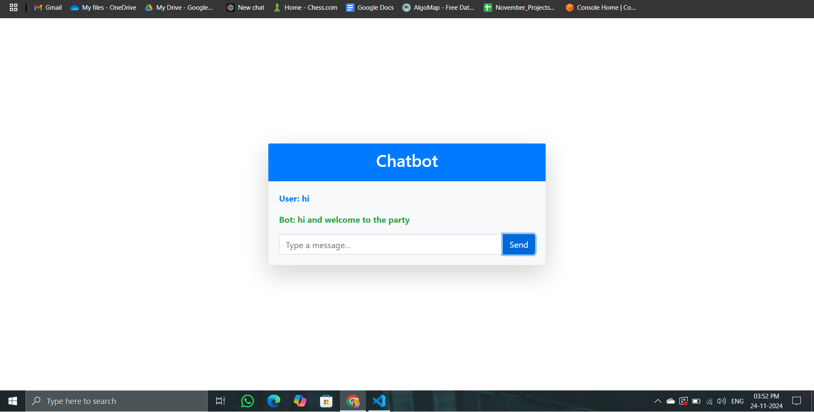

* + Activity 11: Deploy the Chatbot
    - 11.1: Deploy the chatbot to the desired platform.
    - 11.2: Verify functionality and performance.

### 

### 

### 

### 

### 

### Conclusion

The AI-powered chatbot project utilizing AWS Free Tier services successfully demonstrates the integration of various cloud technologies to create a functional and engaging conversational agent. By leveraging Amazon Lex, AWS Lambda, Amazon DynamoDB, Amazon S3, Amazon API Gateway, and Amazon CloudWatch, this project showcases the capabilities of cloud computing in building scalable and efficient applications.